
PHILIPPINE GENERAL HOSPITAL
OUT PATIENT DEPARTMENT
SECTION OF ALLERGY AND IMMUNOLOGY

ALLERGY AND ADR
Follow up Form (1/3)
Patient’s Name ____________________________________ Age _____ Sex _____ Case No ______________

Date of consult
Last seen on
Last working impression

Current Medications

Review of systems | [ ] sneezing [ ] cough [ ] fever  [ ] rhinorrhea [ ] dyspnea [ ] tearing  [ ] congestion [ ] wheals [ ] throat clearing  [ ] postnasal drip [ ] pruritus  [ ] rash __________________________________  [ ] others _________________________________
Severity scale

Triggers
Latest laboratory results
HT / WT
BP / HR / RR
PEFR
General | Normal / mouth breathing / nasal twang  Speaks in sentences / phrases / words //  imminent respiratory distress  Oriented to 3 spheres / disoriented
Hair / Scalp | Alopecia / cradle cap / scaling / rash
Head / Face | Normal / facial tenderness  Facial erythema / pallor / headlight sign / malar rash / discoid rash

ALLERGY AND ADR
Follow up Form (2/3)

Patient’s Name ____________________________________ Age _____ Sex _____ Case No ______________

Date of consult
Eyes | Conjunctivae: pink / pale / injection / cobblestoning  Sclerae: anicteric / icteric  Tearing / discharge / Dennie Morgan fold /  allergic shiners / angioedema
Ears | Pinnae: Normal / abnormal / angioedema  Ear canal: Normal / abnormal _______  Tympanic membrane: discharge / cerumen / cone  of light intact
Nose | Normal / nasal crease / external deformity /  alar flaring / bunny red nose  Septum: Midline / deviated / perforated  Grimacing / allergic salute  Turbinates: Normal and pink  Congested / pale / hyperemic /  Polypoid: L / R / bilateral  Discharge: clear, watery / mucoid / purulent / bloody  Nasal polyps: none / L / R
Oral cavity | Normal / lip angioedema / cheilitis / thrush / oral ulcers  High arched palate / malocclusion / halitosis
Throat | Cobblestoning / hyperemia / tonsillar hypertrophy / exudates / post-nasal drip
Neck, thyroid | Normal / thyromegaly
Lymph nodes | Normal / enlarged  Submandibular / supraclavicular / cervical / preauricular / others
Chest and lungs | Chest wall – N / AbN / accessory muscle use  Breath sounds: normal / decreased / hyperresonant  Fremiti: normal / decreased / increased  Adventitious sounds: rales / wheezes/ rhonchi
Heart | Apex beat = / PMI =  Normal rhythm / irregular rhythm / murmur
Abdomen | Normal / hepatomegaly / splenomegaly / mass / tender
Extremities | Palmar hyperlinearity / edema / joint swelling / clubbing
Skin | Normal / warm / cold / tender  Xerosis / pityriasis alba / keratosis pilaris /  ichthyosis  Macule / papule / maculopapular rash  Wheal / angioedema  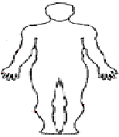  Pustule / nodule / wart  Vesicle / bullae / scaling  Crusting / plaque / patch /  lichenification / excoriations  Hypo- / hyperpigmentation /  Erythema  Hot test + or –  Cold test + or –  Dermatographism + or –  Target lesions: Absent / present  Epidermal detachment: _______ % TBSA  Mucosal involvement: Absent / =1 / >1  Nikolsky’s sign: Absent / present
Pulses | Full / equal

ALLERGY AND ADR
Follow up Form (3/3)

Patient’s Name ____________________________________ Age _____ Sex _____ Case No ______________

Date of consult
Present working impression

Diagnostics

Medications
Referrals
Next ffup on
Examined by

PHILIPPINE GENERAL HOSPITAL
OUT PATIENT DEPARTMENT
SECTION OF ALLERGY AND IMMUNOLOGY
ALLERGY AND ADR
Follow up Form

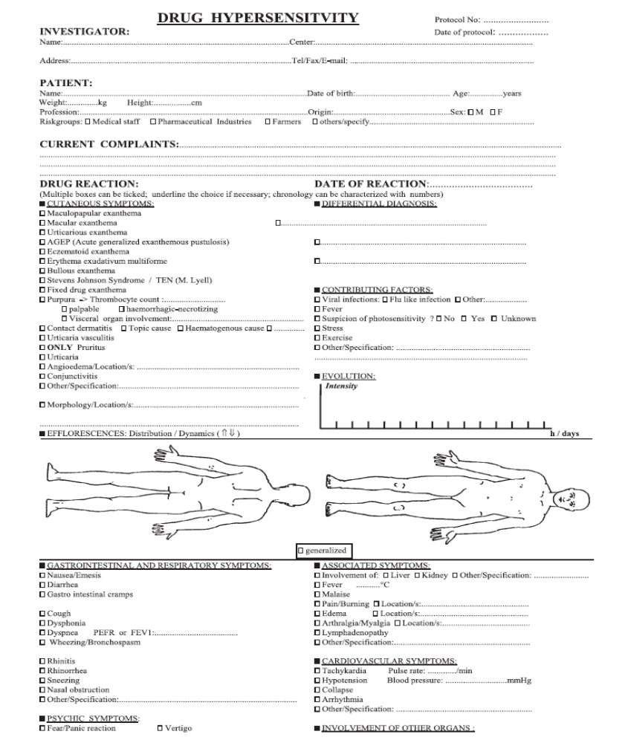

ENDA Questionnaire: European Network for Drug Allergy(Allergy 2009)

